Part 1:

Technical Indicator 1: Simple Moving Average (SMA-20)

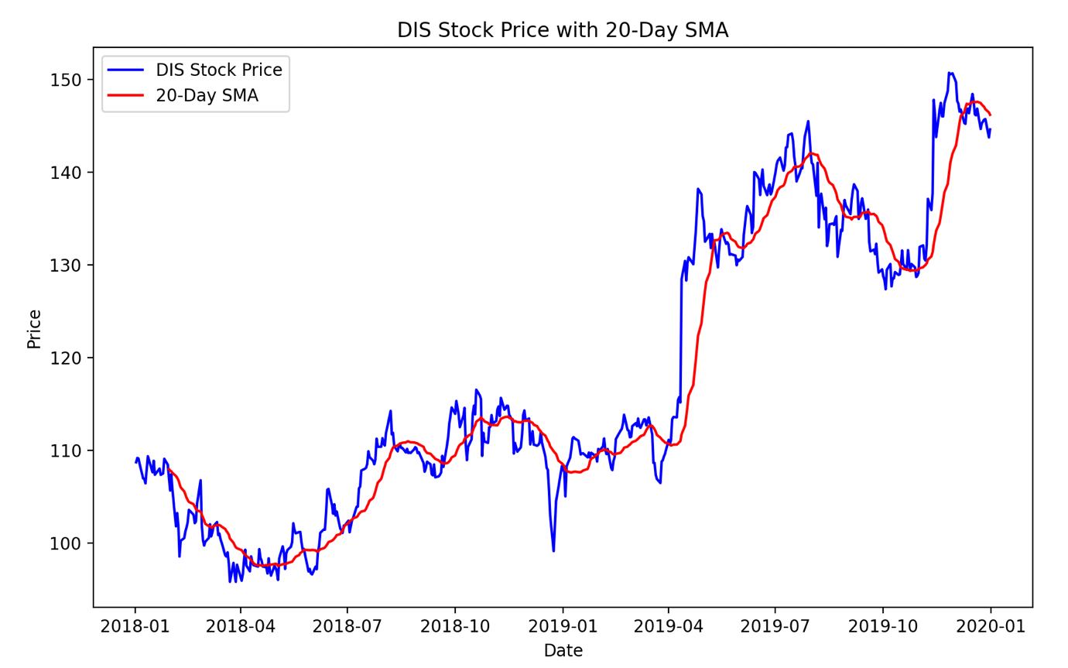

The simple moving average calculates an equally weighted mean for a window that spans n days prior to the current date (n is 20 in this case). There is a lagging look to the SMA-20 because it is reacting to data from the past.

Technical Indicator 2: Bollinger Bands

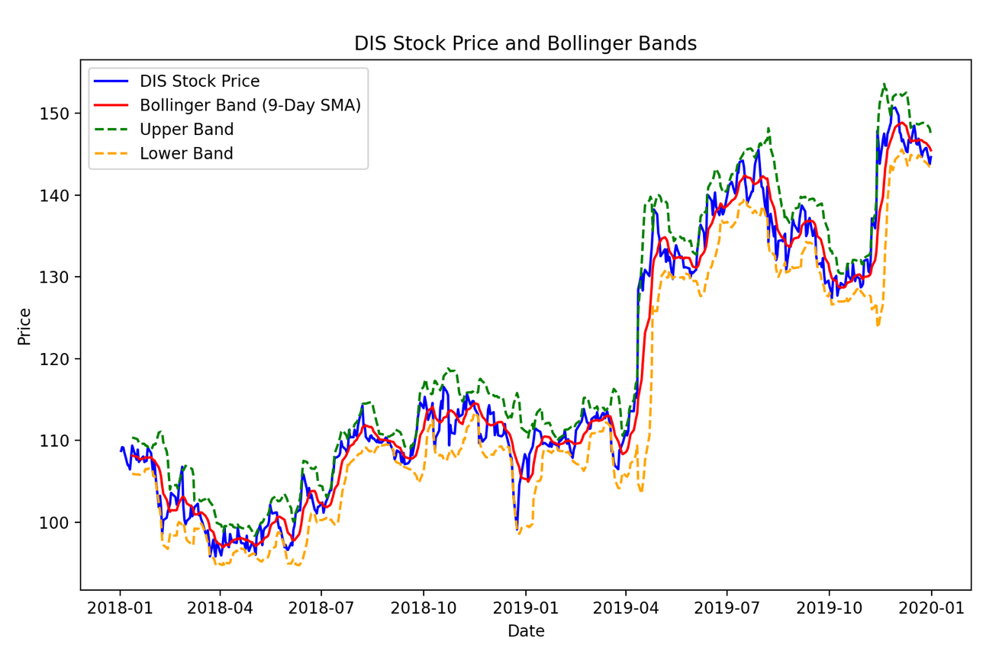

Bollinger bands use the SMA and also consider stock volatility by incorporating an upper and lower band which are two standard deviations above and below the normal SMA band. All three bands still use the weighted mean of the previous n days, there is just now new upper and lower bands.

Technical Indicator 3: Relative Strength Index

The relative strength index is an oscillating indicator designed to measure a stock’s momentum. The RSI is typically used to point to overbought or oversold securities which are indicated when the RSI curve passes beyond 70 (overbought, time to short) or falls below 30 (oversold, time to buy). The RSI is calculated as follows:

The initial average gain must be calculated before we can calculate the average gain. The initial average gain is just the average gain over the first 14 days and likewise for the initial average loss.

**Initial Average Gain =***Sum of Gains over the past 14 days / 14*

**Initial Average Loss =***Sum of Losses over the past 14 days / 14*

This value can be used to find the RSI for the first 14 days.

For each day beyond the 14th day we can calculate the average gain and average loss as follows:

Avg. Gain = [(Previous Avg. Gain * 13) + Current Day's Gain] / 14

Avg. Loss = [(Previous Avg. Loss * 13) + Current *Day's Loss] / 14*

These values can then be used to calculate the RSI for each day beyond the 14th day using the initial formula from the start.

Technical Indicator 4: MACD

The moving average convergence oscillator makes use of two size moving average windows. The MACD above uses an exponential moving window of 12 compared to one of 26. The shorter-term moving average (EMA-12) represents a short-term trend for the stock and the longer-term moving average represents a longer-term trend.



For reference, the EMA-n is calculated as follows:

Part 2:

Cumulative return for the baseline strategy: 0.1795

Cumulative return for the oracle strategy: 2.786

Average Daily Returns return for the baseline strategy: 0.00035802998911805113

Average Daily Returns for the oracle strategy: 0.0026593949440354005

Standard Deviation of daily returns for the baseline strategy: 0.007662005123031564

Standard Deviation of daily returns for the oracle strategy: 0.002793683947517977

Part 3:

My strategy combined the use of two technical indicators, the relative strength index (RSI) and the the moving average convergence oscillator (MACD). The strategy worked by asking both indicators for their opinion on whether to go long, short or hold and then combining the opinions for a final decision. These opinions were stored as follows where 0 refers to HOLD, 1 is LONG, and -1 is SHORT. The RSI suggested a short position when the RSI value on that day exceeded 87, it suggested a long position if the RSI value fell below 32 and suggested a hold if the RSI value was inside the 87-32 band. As for the MACD indicator, a short position was suggested when the MACD value went from above to below the signal-line set at 2.3, a long position was suggested when the MACD value went from below to above the signal line, and a hold was suggested if the previous day’s MACD value had stayed the same side of the signal line as the current day’s. The opinions of the indicators were combined by summing their suggestions (0,1,-1) and a long position was assumed if the total was greater than 0 and a short position was assumed if the total was less than 0, else the stock was held at whatever position it was the previous day.

The MACD and RSI indicators were chosen to follow a theme of momentum. Both indicators try to play on the idea that momentum “turns” before price. The threshold values of 30 and 70 for RSI were chosen to begin with because they are commonly used. Through testing I found 32 and 87 to be the most successful for the in-sample date range. As for MACD, I played with different signal-lines and found that a signal-line at 2.3 was beneficial.

The green lines represent long positions and the red are short.

Cumulative return for the baseline strategy: 0.17999823511479773

Cumulative return for the my strategy: 0.32436025000000024

Average Daily Returns return for the baseline strategy: 0.0003590255300511736

Average Daily Returns for the my strategy: 0.0005847230966588594

Standard Deviation of daily returns for the baseline strategy: 0.007682302990761144

Standard Deviation of daily returns for the my strategy: 0.007099243576171776

Part 4:

|  |  |  |
| --- | --- | --- |
|  | In-Sample | Out-of-Sample |
| Cumulative Return | Baseline: 0.179998  My Strategy: 0.324360 | Baseline: 0 .033576  My Strategy: -0.275849 |
| Average Daily Returns | Baseline: 0.000359  My Strategy: 0.000585 | Baseline: 0.000214  My Strategy: -0.000423 |
| Standard Deviation of Daily Returns | Baseline: 0.007682  My Strategy: 0.007099 | Baseline: 0.017288  My Strategy: 0.020937 |

We can see that my strategy was not very effective on the out of sample date range. A contributor to this would be overfitting as I did fine tune my strategy using the in-sample data. Another reason for its ineffectiveness could be MACD’s ability to signal a false positive, i.e signal a reversal in price that never actually happens. The two indicators also have lag which can be seen to have an impact on the out-of-sample performance. For example, the first short occurs just after the dip that prompted it, and the price then proceeds to rise causing a loss. This effect of lag can be seen elsewhere as well. Lag serves to confirm long term trends but clearly has no predictive power.